**Module Title**

**Internet Technologies**

**Assessment Weightage & Type**

**Portfolio Coursework**

**Year**

**2024-25**

CS & DF- L3_sem-2

**Student Name: Osama Jat**

**UWE ID: 24030174**

**Assignment Submission Date: 26-6-2024**

**Week: 3**

1. **Downloaded Git**

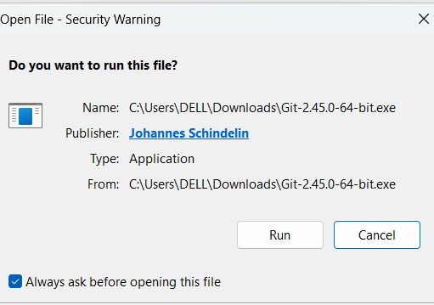

2.Installed Git

3.Created a Folder in Desktop with name “L3” and Right Click on folder L3 and **Select Git**

**Bash Here**

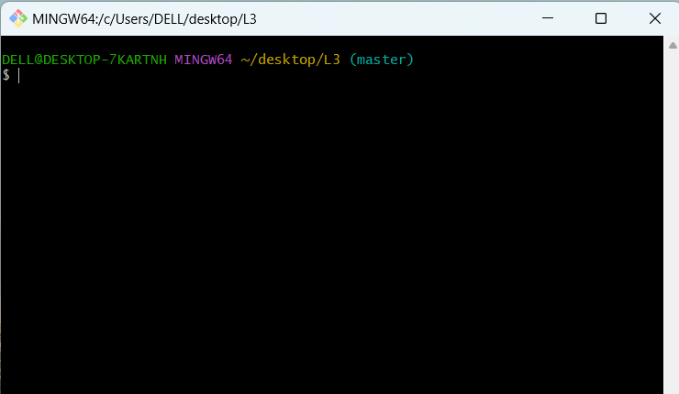

4.cheked git version

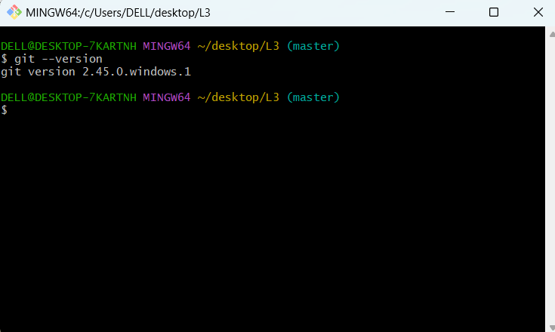

5.Now add files with this Command:

• *touch index.html*

• *touch about.html*

• *touch resources.txt*

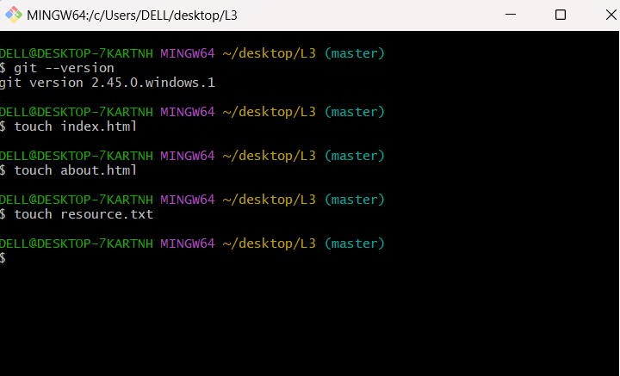

6.chaked folder

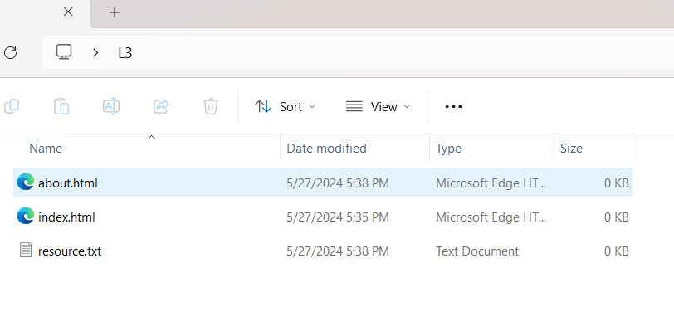  
  
8.  
  
  
  
  
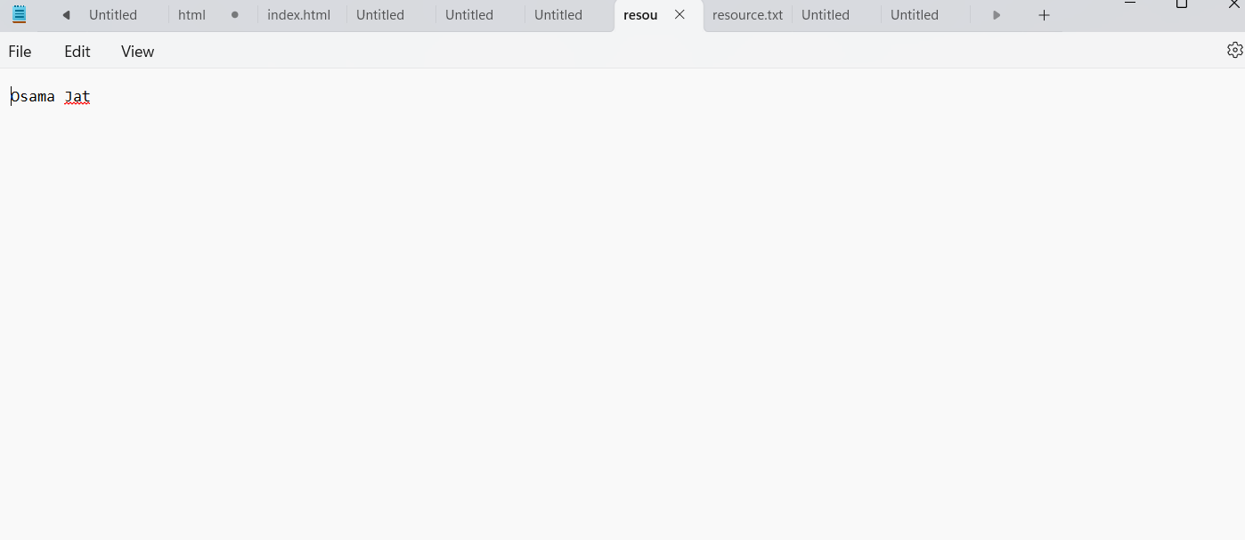  
  
7.  
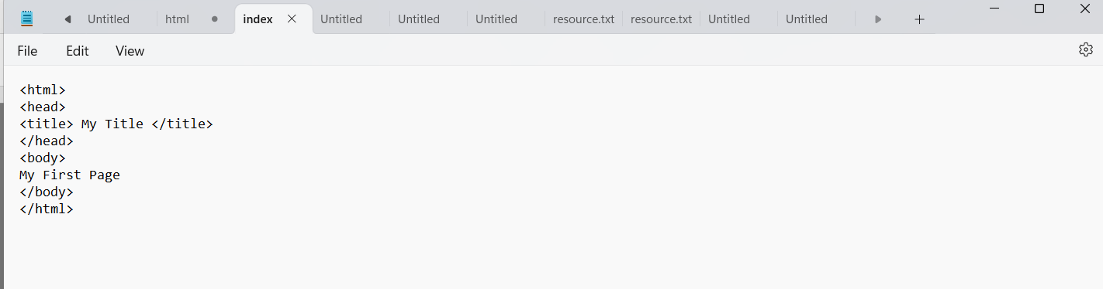

9.

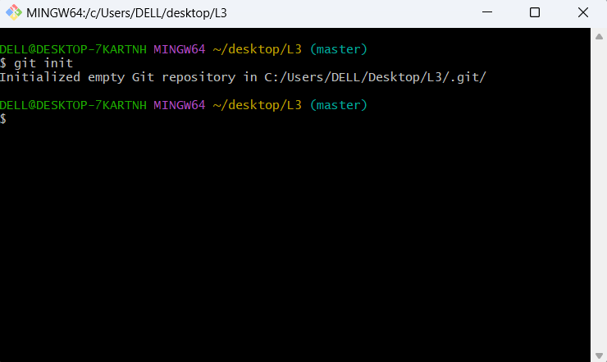

10.  
  
  
  
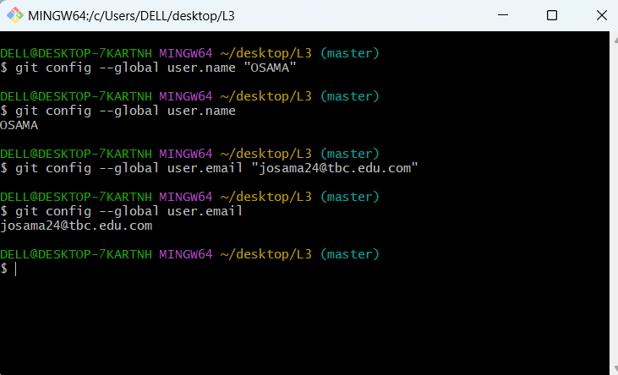  
  
  
  
  
  
  
  
  
  
  
  
  
  
  
  
  
  
  
  
  
  
11.

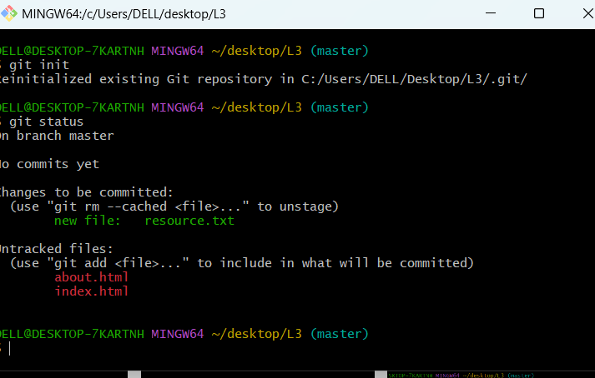

12.

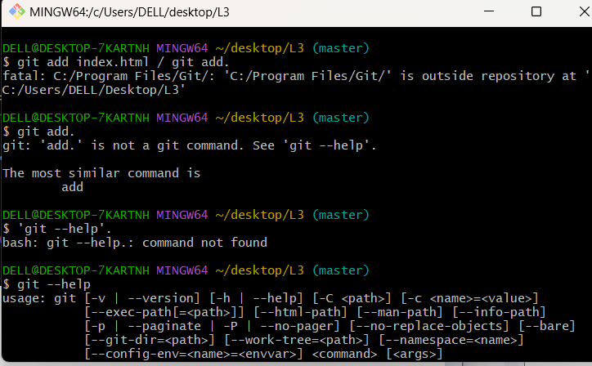

13.

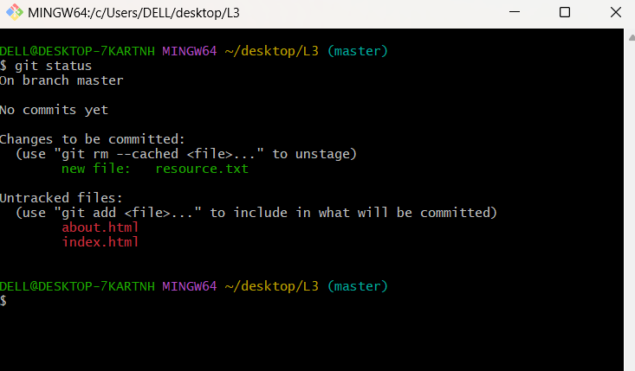  
  
  
  
14.

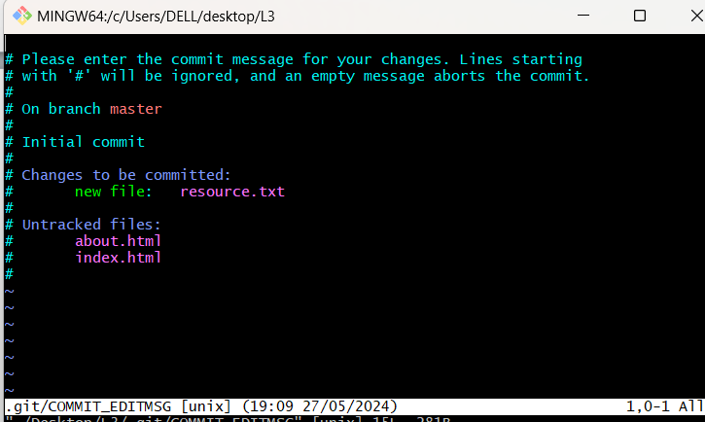  
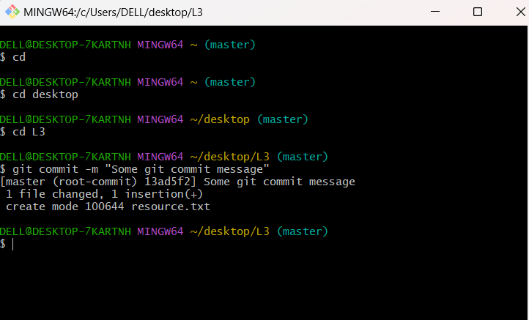  
  
  
  
15.

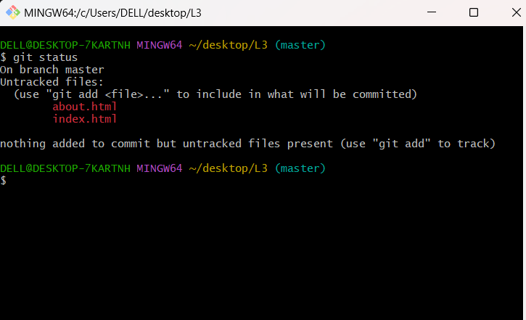

**Task 2 – Git & Github**  
  
1. 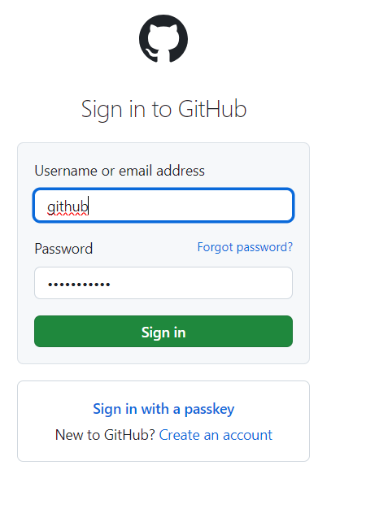  
  
  
  
  
  
  
  
  
  
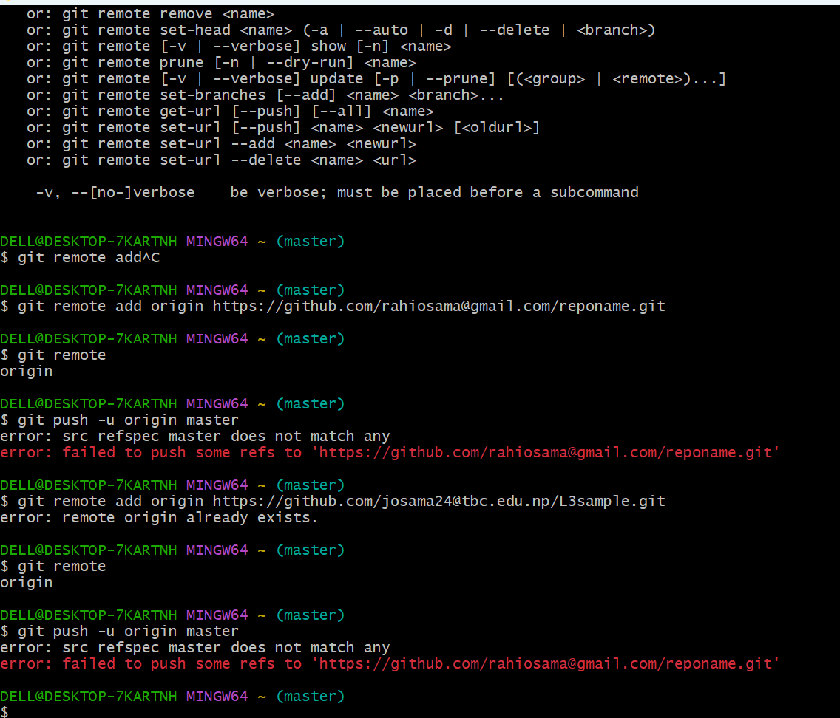  
  
  
  
  
  
  
  
  
  
  
  
  
  
  
  
  
**Task 4 – GUI**

